A1357-Am,C-Costa Rica-Nicoya-Guanacaste Culture-Axe God-Jade-600-1000 CE

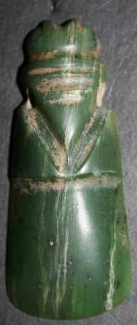 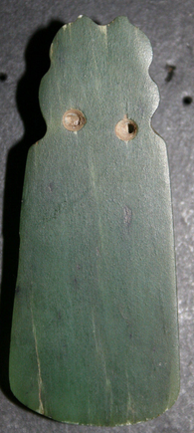

Am,C-Costa Rica-Nicoya-Guanacaste Culture-Axe God-Jade-600-1000 CE

**Formal Label:** Am,C-Costa Rica-Nicoya-Guanacaste Culture-Axe God-Jade-600-1000 CE

**Accession Number:** A1357

**Display Description:**

**Jade was considered to have protective powers for the individual who wore it as an amulet. Therefore, to have a celt god as a symbolic protector was to have a weapon against any challenge to the human spirit or to the body.**

Costa Rica is located,south of Nicaragua and to the north and west of Panama. It is bounded on the west by the Pacific Ocean and on the east by the Caribbean Sea. Although its area is only 19,652 square miles (51,100 square kilometers) Costa Rica's terrain and climate are quite varied. Central Costa Rica is dominated by verdant volcanic mountain ranges, while humid tropical forests occupy the low-lying territories on the east coast and the southern part of the Pacific coast. In contrast, Guanacaste and the Nicoya Peninsula in northwestern Costa Rica are comparatively arid, with pronounced seasonal fluctuations in rainfall.

Sculptures of carved volcanic stone, breastplates and pendants of cast and hammered gold or highly polished jade, and beautifully modeled and painted ceramics dating from around 500 B.C. to the time of the first contact with Europeans in the early 1500s reveal the natural, social, and spiritual world of the region's people. Many works depict animals, especially those that exhibit aggressive, predatory, or dangerous behavior (like the crocodile, jaguar, and harpy eagle). Humans (both men and women), often holding or wearing items that reveal occupation or rank, are also popular subjects. Many human figures have non-natural features (like wings or animal heads) that may represent special powers or spiritual or social affiliations. Some works seemingly give evidence of shamanism, in which spiritually powerful individuals transformed themselves in order to visit the spirit world. Shamans reputedly had the ability to heal the sick and could also cause illness or injury.

The first Europeans to reach Costa Rica, in 1502, were members of Christopher Columbus's fourth voyage. His expedition explored the Caribbean coast of Costa Rica, Nicaragua, and Panama, and he and his men interacted with both local inhabitants and maritime traders. Accounts of the voyage note that local peoples were wary and frequently bellicose, yet they were usually eager to trade. Anxious to discover wealth, Columbus was especially interested in gold. He bartered for gold ornaments and inquired assiduously about sources of the precious metal in the newly discovered region.

**Date or Time Horizon:** 600-1000 CE

**Geographical Area:** Costa Rica-Nicoya

Map:

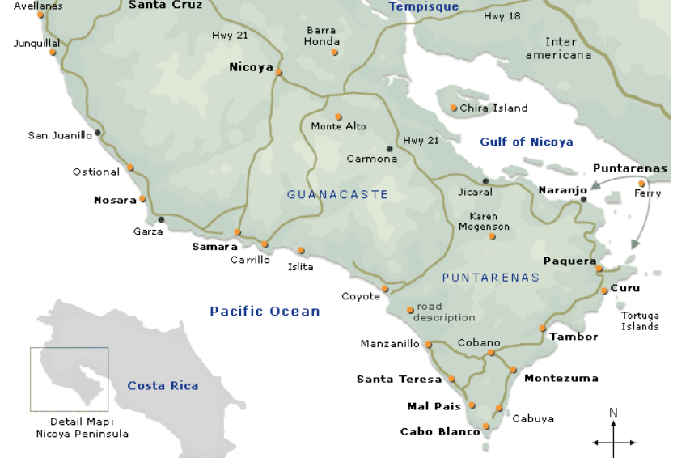

**GPS:** 10°09'1.37" N -85°27'3.35" W

**Cultural Affiliation:** Guanacaste Culture

**Medium:** Jade

**Dimensions:** 2.28 in, 57.90 mm

**Weight: 13.4 oz, 12.6 g**

**Provenance:** Nicoya

**Condition:** original

**Discussion:**

Spanish accounts of the region's peoples in the 1500s describe small, warlike groups led by caciques, or chiefs, that formed shifting alliances and traded actively with one another and with long-distance traders from the north and the south. The villages the Spaniards encountered lacked masonry architecture, and monumental stone sculpture was rare. Buildings were made of wood and thatch but could be very large. Written language in the form of either inscriptions or books was unknown. In common with all of the Americas before European contact, the region's peoples lacked draft animals and wheeled vehicles, iron technology, and gunpowder.

From about A.D. 600 until the 1500s, the typical Costa Rican political organization was chiefdoms which were and less complex and hierarchical than states with villages ruled by chiefs who had spiritual power and a hereditary office that had to have been confirmed through skill as a warrior and as a politician.

Panama and Costa Rica at the time of Spanish conquest had a population of about 2.2 million (Ibarra 2003, 392), but diseases, warfare, and slavery soon took their toll. Costa Rica's sixteenth-century peoples were ethnically and linguistically diverse, but it is believed that the majority of the population spoke Chibchan (a family of languages also spoken in Panama and Colombia). Nahua and Mangue languages were spoken in northwestern Costa Rica and southeastern Nicaragua by the descendants of successive waves of migrants into the region from Mexico and Guatemala (Hoopes and Fonseca Zamora 2003). Unfortunately, early Spanish chroniclers often identified groups by the name of their chief and were unclear on their ethnic or linguistic affiliations.

When conquistador Gil Gonzalez Dávila entered Nicoya in 1523, it was the largest cacicazgo (chiefdom) on the Pacific coast of Costa Rica. Though it is often surmised that the city and peninsula of Nicoya derive their name from a cacique Nicoa (or Nicoya) who welcomed Dávila and his men, actually Nicoya took its name from the Nahuatl appellation Necoc Īāuh, literally "on both sides its water(s)", as Nicoya is in fact situated between two major rivers. The Peninsula de Nicoya is itself named for the city, Nicoya being the most important town in that area.

The treasurer on Dávila's expedition, Andrés de Cereceda, reported a population of 6,063 inhabitants under Nicoya's leadership, almost five and a half times larger than the next largest settlement visited by the Spanish along the Pacific coast in the early 1520s (Peralta 1883:29–31). According to 16th-century chronicler Gonzalo Fernández de Oviedo y Valdés, who visited Nicoya in 1529 (Meléndez 1959:363), the layout of the indigenous community was similar to that of the larger settlements in nearby Nicaragua and included a central plaza with temples, a low pyramidal mound used for human sacrifice, and specialized plazas for markets and chiefs' residences.

Many of the earliest colonial documents about pre-Columbian Nicoya appear to have been lost in a fire that burned the town's archives in 1783(ANCR Exp. 273). In the resulting documentary vacuum, a number of interpretations regarding pre-Hispanic Nicoya have emerged. Foremost among them is the belief that as the southernmost representatives of Mesoamerican culture, Nicoyans lived in nucleated villages, and that Cereceda's accounting of 6,063 souls merely represented the number of inhabitants of one village under chief Nicoya's contr (Meléndez 1959). The modern city of Nicoya is generally believed to be on the site of that village.

The center of Nicoya is spatially organized in the traditional Spanish-American pattern, with a central plaza surrounded by streets ordered in a grid pattern aligned with the cardinal directions. Atypically, the church is in the northeastern corner of the central plaza, not facing the plaza from a surrounding street, as was the Iberian norm. Today the church is locally referred to as the *templo colonial*; local oral history maintains that the church dates from sometime between 1522 and 1544, when the parish of Nicoya was founded, probably on the site of the temple of the gods that the indigenous population had previously used for worship, since this was the typical Spanish way of desacralizing the previous religion and resacralizing it to Spanish Catholicism.

The eminent Costa Rican historian Carlos Meléndez took note of the unusual location of the *templo colonial* in the urban core of the city and, based on Oviedo's brief description of the indigenous community, hypothesized that the church had been built atop the indigenous sacrificial mound. Meléndez's hypothesis fits the known Spanish pattern of direct superimposition of Catholic politico-religious structures on indigenous structures t. In short, Meléndez argued that the location of the colonial church is not merely an aberration from the common Iberian pattern of facing the plaza but is coincident with the location of the sacrificial mound in the northeastern corner of the plaza of indigenous Nicoya as described by Oviedo in 1529 (Meléndez 1978).

However, archaeological excavations were conducted in and around the city of Nicoya in the early 1990s to test these theories and to better understand how the indigenous community was transformed into a colonial town (Lawrence 2005, 2009). Excavations in the center of Nicoya failed to produce any evidence of a substantial pre-Columbian presence in the city's center. Investigations into the surrounding valley failed to identify unequivocally a single site as the probable home to Nicoya. However, several large (5–10 hectare/12–24 acre) archaeological sites were in similar ecological niches throughout the valley. They are situated along river and stream banks at the point where streams leave the hills that surround the valley and cross the undulating valley floor.

[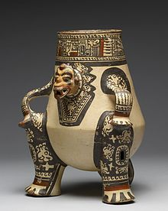](https://en.wikipedia.org/wiki/File:Guanacaste-Nicoya_-_Shaman_Effigy_Vessel_-_Walters_20092056_-_Three_Quarter_Left.jpg)

This Pataky ceramic (late Period VI, AD 1000-1350) portrays a seated shaman transformed into a jaguar spirit companion form.

At least two of these sites are considered likely candidates for protohistoric Nicoya. One is just outside contemporary Nicoya along the banks of the Rio Chipanzé. The other is in the hamlet of Sabana Grande, six kilometers north of Nicoya. This site appears to be larger than the rest; it exhibits low earthen mounds and is particularly prized by local looters for its high-quality polychrome pottery and gold artifacts. Apparently a much greater quantity of high-quality artifacts have been removed from the vicinity of Sabana Grande than from Nicoya or anywhere else in the valley. Furthermore, it is interesting to note that the colonial *ejido* (lands held in common by the indigenous community) of the Indian community of Nicoya was in Sabana Grande, not Nicoya (ANCR Exp. 301; Exp. 792; Exp. 3710).

It is only possible to consider either of these sites as protohistoic Nicoya if we discard the notion that it was a single community of over more than 6,000. Neither site is near the size necessary to hold that number of people if we accept even as an approximate Newson's (1987:87) estimates of 0.045 to 0.06 persons/hectare for Pacific Nicaragua at Spanish contact, and as little as 0.02 persons/hectare for Nicoya. A closer reading of the ethnohistoric material in conjunction with the archaeological information is necessary to form a more realistic picture of Nicoya on the eve of conquest. It is worthwhile returning to Andrés de Cereceda, treasurer of Gil Gonzalez Dávila's 1522 expedition, and review his own words in regard to Nicoya:

"The chief Nicoya is five leagues further on, inland: they baptized 6,603 souls; he gave 13,442 pesos in gold, with a little more that the chief Mateo gave" (Peralta 1883: 30).

Cereceda's figure of 6,603 is typically taken to represent the number of inhabitants of the *cacique*, Nicoya's town, but Cereceda never makes that assertion, only that the expedition baptized that number of people. Furthermore, he refers to a second chief, Mateo, whose residence was never specified.

An alternative interpretation of Cereceda's figures would understand them as representing the inhabitants of several settlements politically affiliated with Nicoya but not the members of one massive community. The *cacique* Nicoya may not have had tributary villages under his direct control. But it is not unlikely that there were several villages within his orbit of influence that he could persuade to treat with the Spanish. A model of dispersed settlement of politically affiliated villages rather than one large nucleated town better fits the archaeological and ethnohistoric information. Oviedo, who visited Nicoya in 1529 and recorded aspects of the town's layout, never remarked on the great size of the settlement. Oviedo was in Nicoya before precipitous population decline had taken its effect, and one would expect some remark from this astute observer had Nicoya been such a populous and highly nucleated center.

If the above hypothesis is true, what does modern-day Nicoya represent historically? Among other tools of colonial administration, the Spanish crown created a policy called *congregación*, or the forced resettlement of native peoples into nucleated settlements to more closely watch and control their charges. The evidence leads one to further hypothesize that the present-day Nicoya is the product of Spanish colonial *congregación*, formed by the forced amalgamation of people from the pre-Hispanic settlements dispersed throughout the region. When this may have been done, and under what circumstances, are unknown. As mentioned above, the historical documents, which would have recorded such an event, would have been lost in the 1783 fire that completely destroyed the colonial archives in Nicoya. Further research in other repositories may yet provide confirmation for this interpretation.

**References:**

BASKES, JEREMY (2000). "Indians, merchants, and market: a reinterpretation of the Repartimiento and Spanish-Indian economic relations in colonial Oaxaca, 1750-1821." stanford: Stanford University Press.

FERNANDEZ GUARDIA, RICARDO (1938). "La sublevación de los indios de Nicoya en 1760." In *Revista de los Archivos Nacionales,* 2:362-366.

LAWRENCE, JOHN W. (2005). "La Arqueología, la historia y la memoria: Interfaces interpretativas en la historiografía colonial de Nicoya, Guanacaste, Costa Rica." In *Memorias del Coloquio Internacional 'Universos Coloniales Centroamericanos'.* Universidad Rafael Landívar: Guatemala City, Guatemala.

LAWRENCE, JOHN W. (2009). "Archaeology and Ethnohistory on the Spanish Colonial Frontier: Excavations at the Templo Colonial in Nicoya, Guanacaste, Costa Rica." In *Historical Archaeology* 43(1):65-80.

MELENDEZ CHAVARRIA, CARLOS (1959). "Tipos de población de Costa Rica a mediados del siglo XVI." In *Actas,* 33rd International Congress of Americanists. Vol. 2., pp. 485:494. San José: Imprenta Lehman.

MELENDEZ CHAVARRIA, CARLOS (1978). "Nicoya y sus templos historicas." In *Separatas No. 38.* San José: Universidad de Costa Rica.

MELENDEZ CHAVARRIA, CARLOS (1983). "Primera Etapa de la Encomienda de Indios en Nicoya 1524-1545." In *America Indígena,* 43(1):187-204.

NEWSON, LINDA (1987). *Indian Survival in Colonial Nicaragua.* Norman: University of Oklahoma Press.

OVIEDO Y VALDEZ, GONZALO FERNANDEZ DE (1959). *Historia General y Natural de las Indias.* Madrid: Ediciones Atlas.

PERALTA, MANUEL M. DE (1883). *Costa Rica, Nicaragua y Panamá en el Siglo XVI.* Madrid: Murrillo.

**Appendix:**

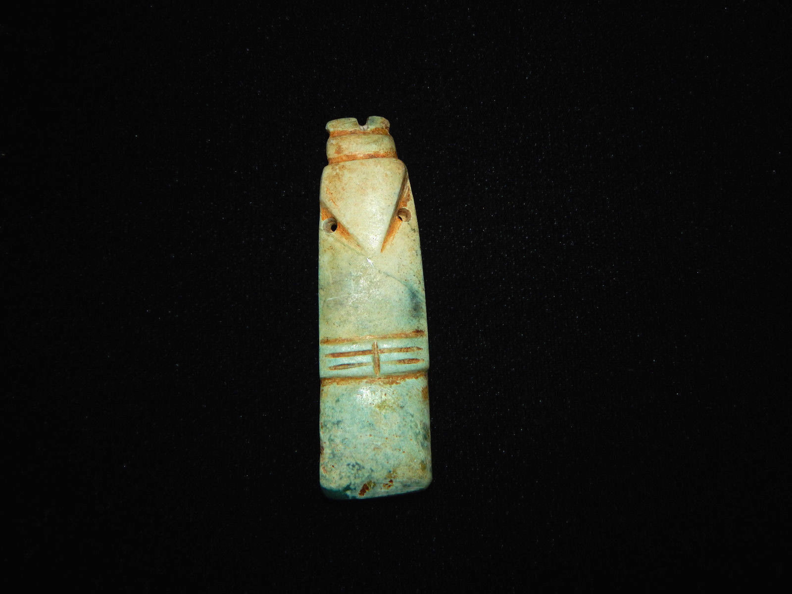

Pre-Columbian Avian Jade Axe God Pendant  
Avian Axe God Pendant Carved from Jade, Beautiful Colors, Excellent Condition  
Origin: Nicoya, Costa Rica  
Age: 500-800 A.D.

Price:

US $1,100.00

# *us.e548*